Checking Button – Acceptance Test

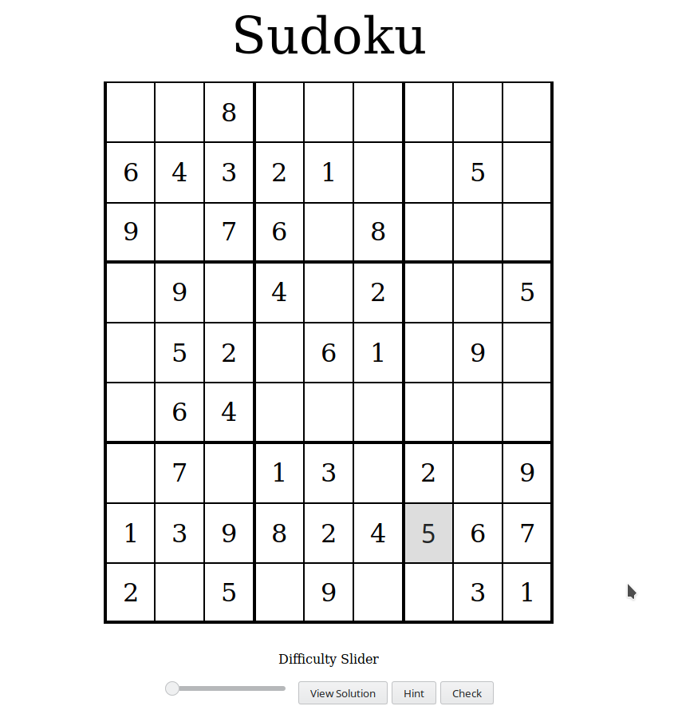

Entered Value is right, value highlighted green

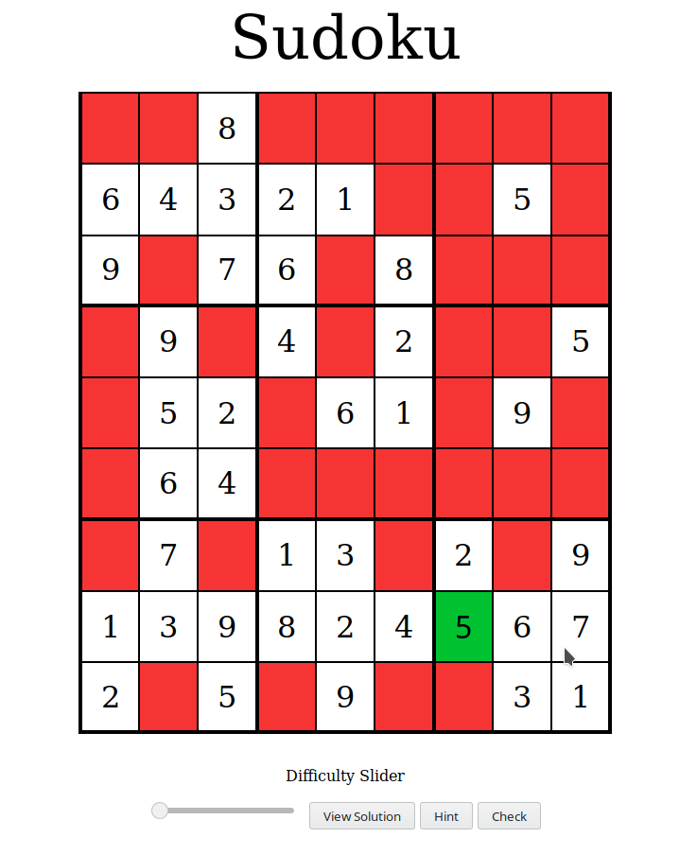

Entered value is wrong, value is highlighted red

